CS 255 System Design Document Template
Rashmi Poudyal

UML Diagrams

UML Use Case Diagram

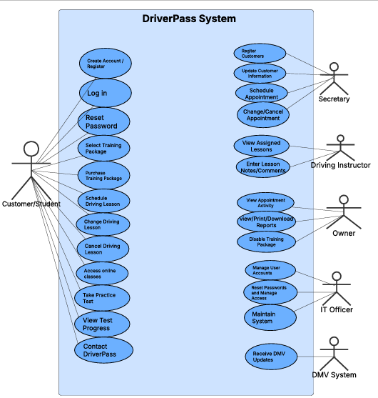

UML Activity Diagrams
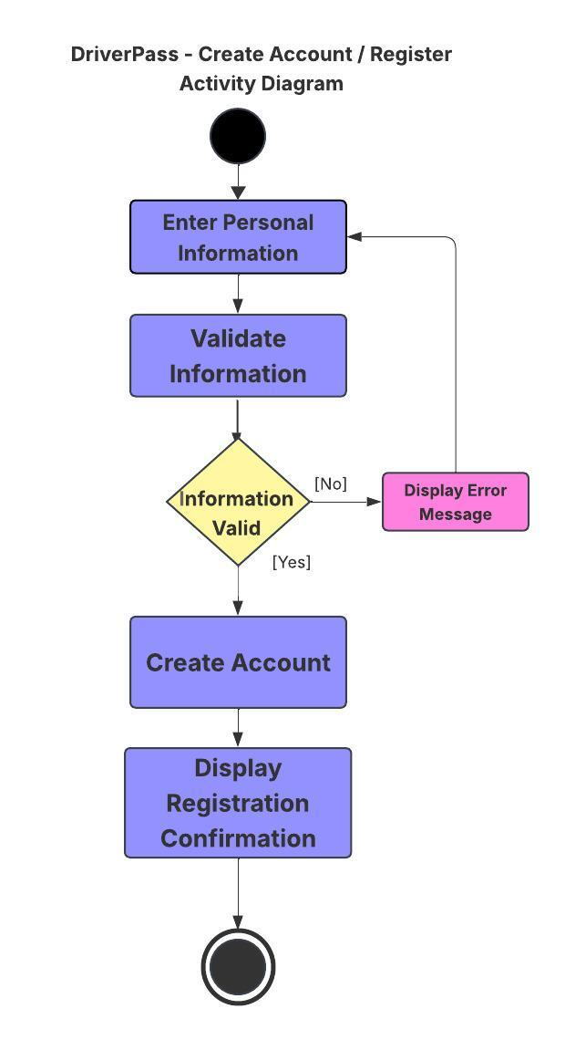
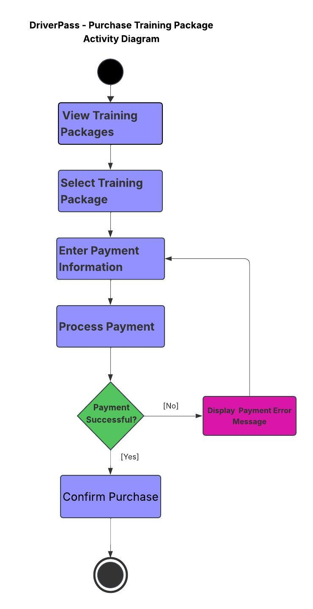

UML Sequence Diagram
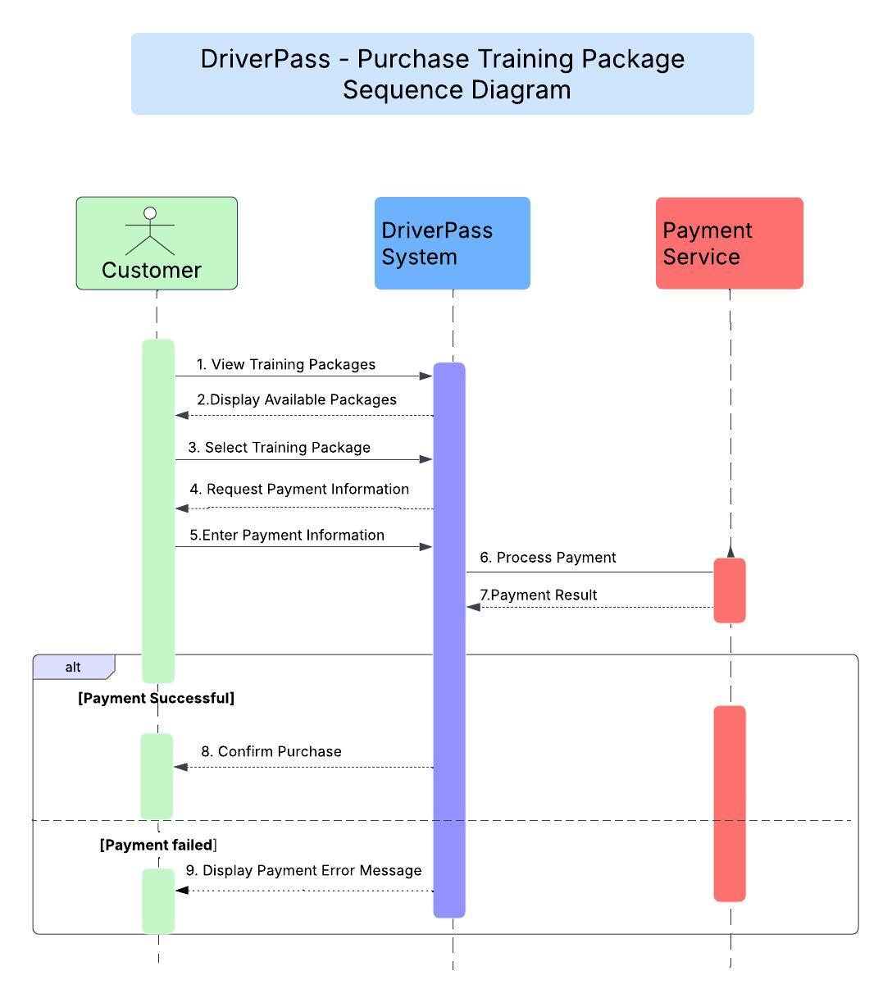

UML Class Diagram
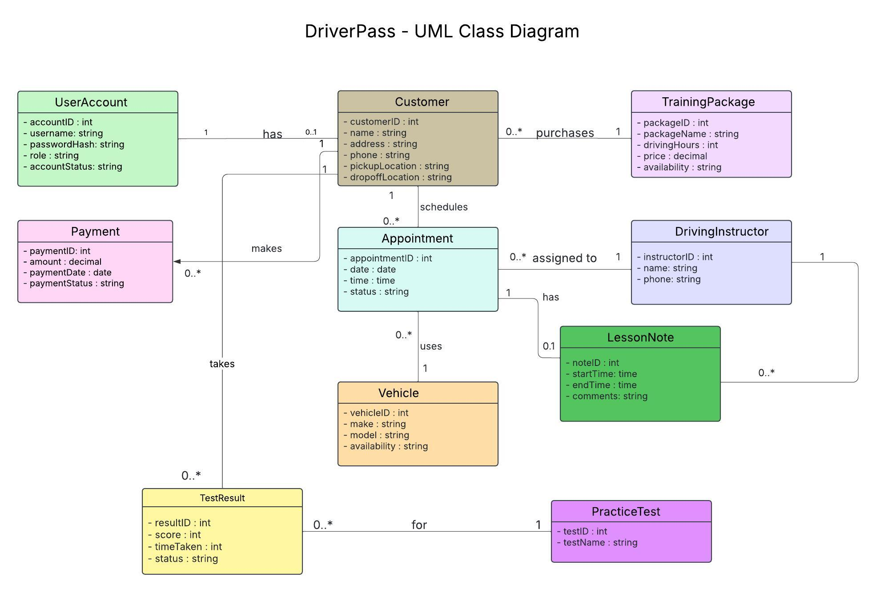

Technical Requirements
In order to use the DriverPass system, customers and employees will need a computer, tablet, or mobile device with internet access. Employees will also need computers to manage customer accounts, appointments, reports, and lesson information.

The system will be web-based and accessible through a web browser. It should work on common devices running Windows, macOS, Android, and iOS. The system will also need a database to store customer information, appointments, payments, test results, training packages, instructor information, vehicle information, and lesson notes.

The system should respond quickly when users log in, schedule lessons, check test results, or view account information. Under normal conditions, most actions should take three seconds or less. Any changes made to appointments or accounts should update immediately.

For security, each user should have their own account, and access should be based on their role. For example, customers, instructors, the secretary, the owner, and the IT officer should only be able to view or modify the information they are allowed to access. Information exchanged between users and the system should be protected using HTTPS and TLS encryption. Passwords should also be stored securely as password hashes instead of plain text.
The system should include a secure payment service for customers purchasing training packages. It should also be able to receive updated rules, policies, and practice test information from the DMV.
The DriverPass system should preferably be hosted in the cloud so the company does not have to manage its own physical servers. The cloud service can provide storage, backups, security, and reliable access. The owner should also be able to download reports for offline use, while any changes to the system should still be made online.

